**PES University, Bengaluru**

**VI Sem**

**Session: January – May, 2020**

**COMPUTER NETWORK PROJECT**

**UE17EC351**

“MULTI-MEDIA FILE SHARING SYSTEM USING CLIENT-SERVER ARCHITECTURE”

Submitted by

**6th B**

**PRATHIMA CHOWDARY**(PES1201700776)

**V SAISRI**(PES1201701763)

**PROBLEM STATEMENT:**

**TO CREATE A CLIENT-SERVER CONNECTION ESTABLISHMENT WHICH CAN BE USED TO SHARE MULTI-MEDIA FILES BETWEEN MULTIPLE CLIENTS**

**INTRODUCTION:**

Chatroom is a feature generally used in various applications which allows multiple users to communicate and share data with each other while within a gaming application or any other website. This feature allows users to send/receive messages, transfer files such as audio, video etc., among users.

Our project implements this feature of exchange of messages and transfer of files among users in a chatroom implemented with Tkinter GUI.

Firstly, a chat server is required and hence created, that responds to the requests sent by the clients wanting to communicate. This was done using socket programming (TCP sockets were used) and the concept of multithreading. Clients are served by accepting new connections, broadcasting messages and handling clients.

Next important thing is a client. Client is provided with a GUI for communication. A client would wish to send/receive messages or transfer files or both. These functions are implemented using Tkinter modules.

**BLOCK DIAGRAM:**

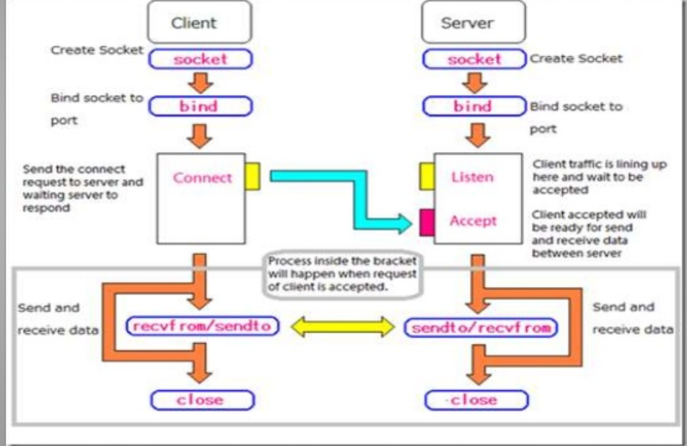

**CONFIGURATION:**

**Modules Developed:**

* Accept incoming connections
* Handle individual clients
* Message broadcasting
* Message transfer
* File transfer

**Network Concepts used:**

* TCP Socket programming

**New concepts Learnt:**

* Multithreading programming
* Tkinter GUI usage and application

**Execution :**

By changing the host address to the required address,we will be able to share files of any device

**CODES:**

**SERVER CODE:**

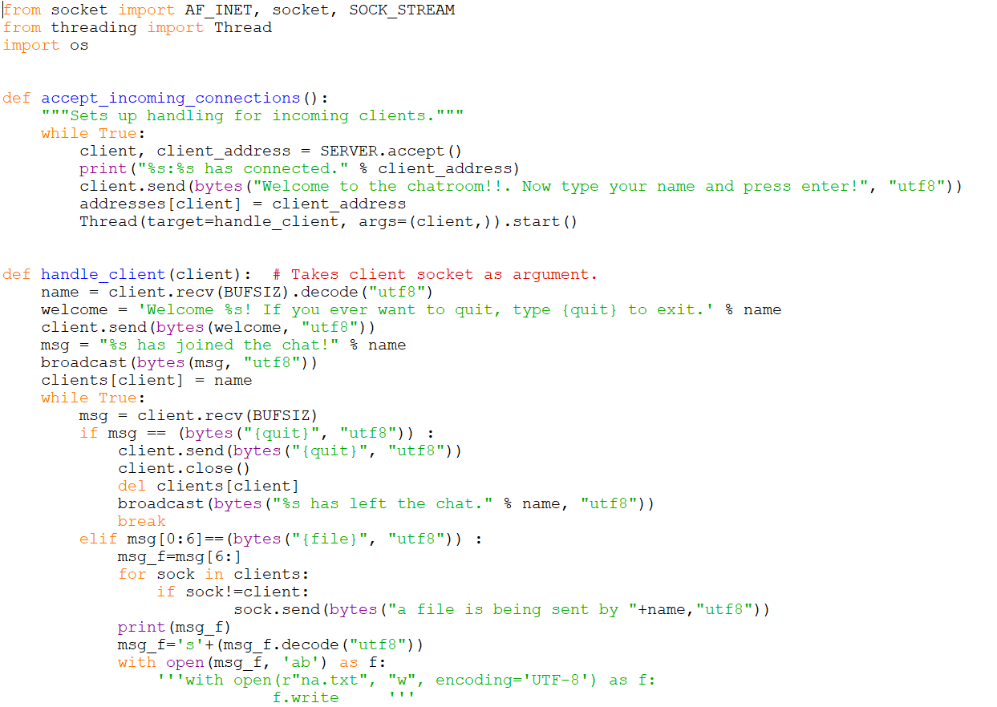

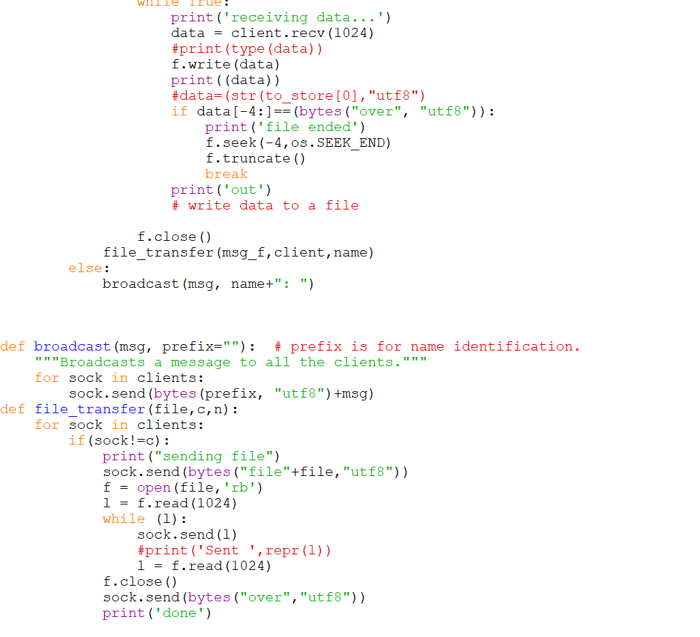

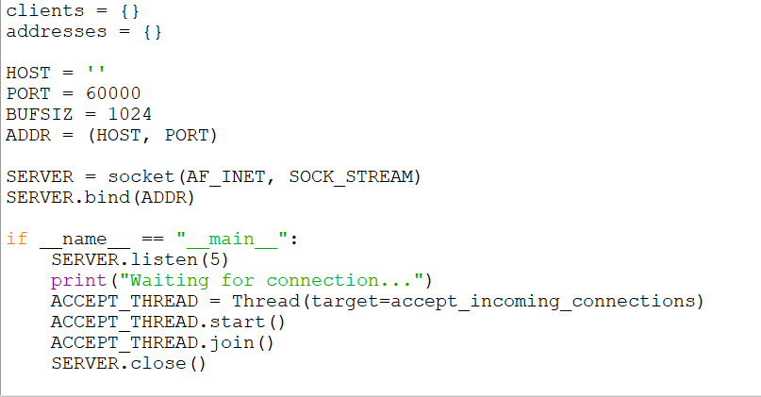

**CLIENT CODE:**

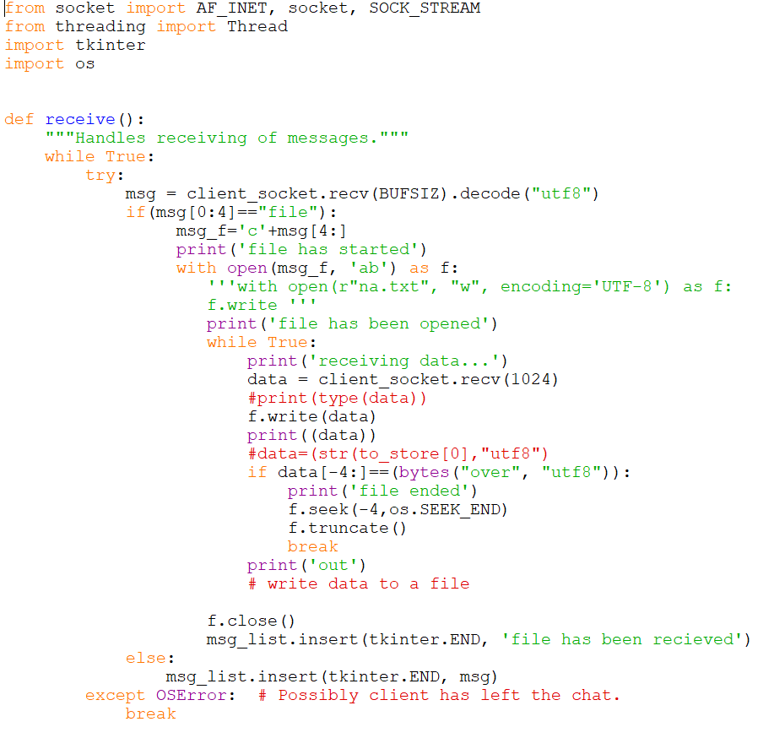

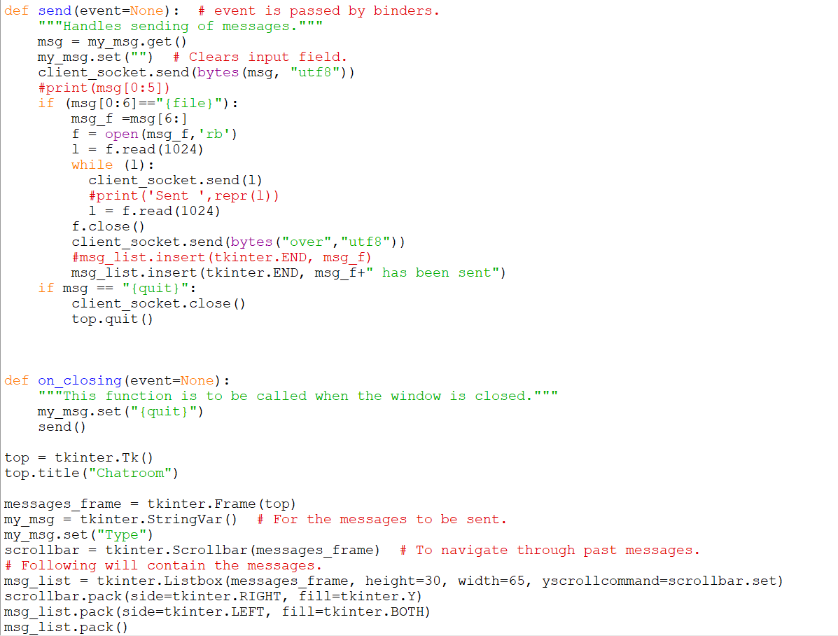

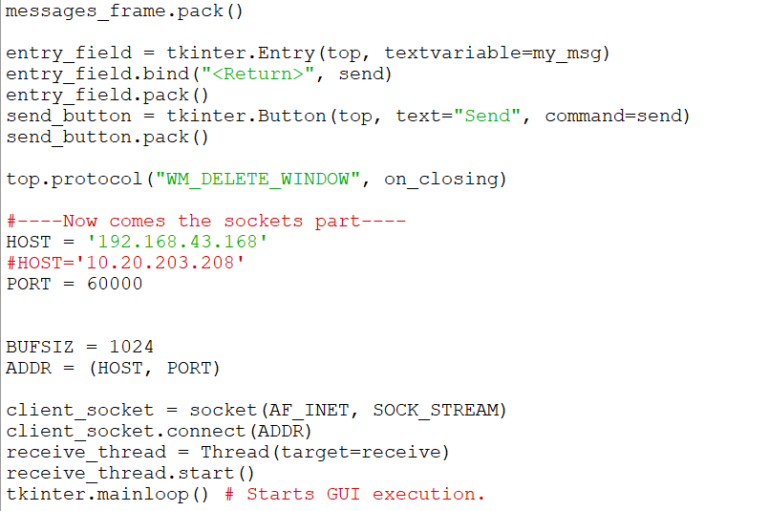

**RESULTS:**

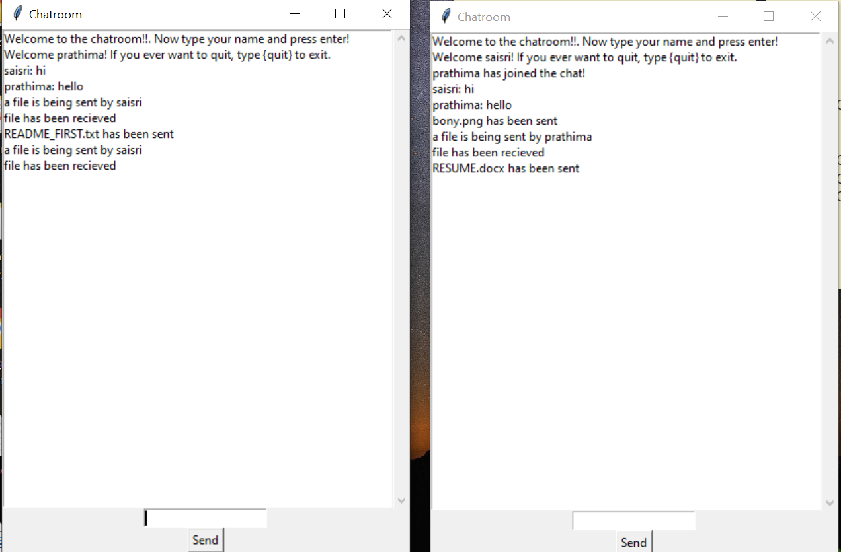

**CONCLUSION:**

By running these codes we are able to share multi-media files between multi-user clients

**Future Scope:**

I can further extend this application in the future effectively by adding this services.

* Extending this application by providing Authorisation service.
* Creating Database and maintaining users.
* Increasing the effectiveness of the application by providing Voice Chat and video calling.
* Extending it to Web Support.

**THANK**

**YOU**